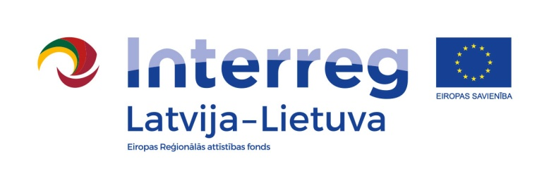

Interreg V-A Latvia-Lithuania Cross Border Cooperation Programme 2014 – 2020 is looking for a skilled and committed Senior Project Management Expert (two positions) with Lithuanian and English language knowledge, experience in project development and desire to extend his/her geographical and professional horizons in international working environment.

Are you interested in developing your experience in international team specialised in supporting cross-border cooperation between Latvia and Lithuania and make use of your good knowledge of English? Then read more about our job offer and apply till 22 July 2016.
We offer:
- Stable salary (ranging from EUR 1 006 to EUR 1 647 before taxes) and social guarantees, as well as monthly payment for employees who have moved from their home country;
- Work in the state institution with opportunity to acquire diverse professional experience and trainings in international programme management and monitoring;
- Good working conditions and responsive team members;
- Work place in the centre of Riga;
- Business trips in Latvia and Lithuania and abroad.

The position is fulltime (40 hrs/week) and based in Riga, Latvia in the Ministry of Environmental Protection and Regional Development of the Republic of Latvia. The contract will be concluded as rapidly as possible and the contract will run until 31 December 2020. Trial period of 3 months will be applied. The successful candidate will be employed in accordance with relevant Latvian labour law.

For more information about requirements and necessary general knowledge and skills: http://www.varam.gov.lv/eng/par_ministriju/vacancies/

