Interreg Baltic Sea Region 2021-2027 Programme document
SUMMARY

The overall programme objective constitutes the umbrella for the Interreg Baltic Sea Region Programme 2021-2027:
‘To put into practice innovative, water-smart and climate-neutral solutions through transnational cooperation for the benefit of the citizens across the Baltic Sea region.’

The following three elements describe the value statement of the Programme:
Supporting transition: The Programme creates suitable framework conditions in the Baltic Sea region for supporting the transition towards greener and more resilient societies and economies through transnational cooperation. Digitalisation is a central enabler in this transition.
Customer orientation: The Programme is demand-driven and support public authorities in meeting the needs of their target groups (e.g. companies and communities).
Transfer of knowledge and capacity building: Transfer of knowledge is an important component of transnational activities in all policy objectives. Future projects support capacity building to increase public awareness and behaviour-change.
In line with the Common Provision Regulation, the Programme ensures that the principles of gender equality and non-discrimination will be applied.
As in previous funding periods, the Programme has carefully been aligned with the EUSBSR (European Union Strategy for the Baltic Sea Region) and its action plan in order to maximise benefits for the BSR citizens.
The Programme targets public authorities at local, regional and national levels, business support organisations, specialised agencies, sectoral agencies, logistic and transport operators and infrastructure and service providers. Wherever appropriate, e.g. for the purposes of practical testing of solutions, the Programme supports direct involvement of enterprises and business support organisations. The Programme emphasises citizen involvement through NGOs. Higher education and research institutions as well as education and training centres may join transnational cooperation actions to support the main target groups with additional expertise and competence.
More information on the programming process is available at https://www.interreg-baltic.eu/post2020.html

PROGRAMME AREA
Interreg Baltic Sea Region covers eleven countries, eight of them EU Member States (Denmark, Estonia, Finland, Germany*, Latvia, Lithuania, Poland and Sweden) and three partner countries
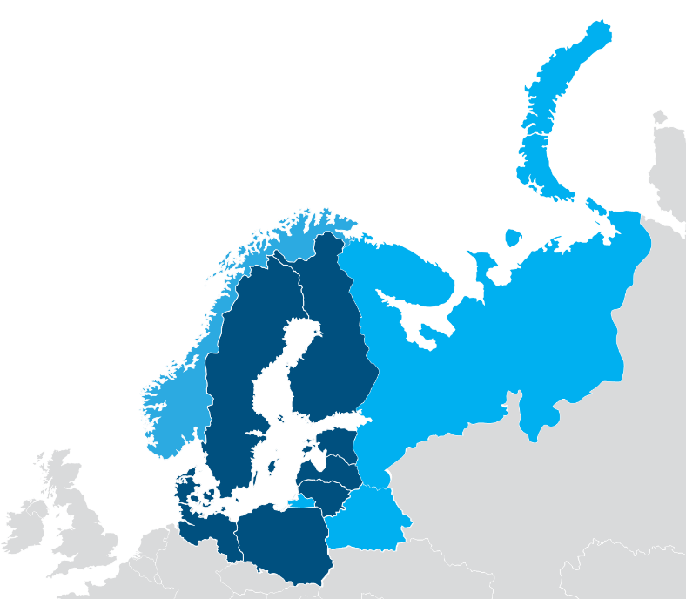
(Belarus, Norway** and Russia*). The Programme covers an area of around 3.8 million km² with a population of more than 103 million inhabitants. It stretches from central parts of Europe up to its northernmost periphery, comprising European metropolitan areas, while major parts of the programme area are counted as rural.

*Only parts, as displayed in the map
** The two northern regions of Norway (Nordland and Troms og Finnmark) will not belong to
the IBSR Programme 2021-2027. The map will be updated accordingly

STRATEGY AND THEMATIC FOCUS
Four priorities including nine Programme objectives best reflect the needs for transnational cooperation identified by the Programme countries for the next seven years.
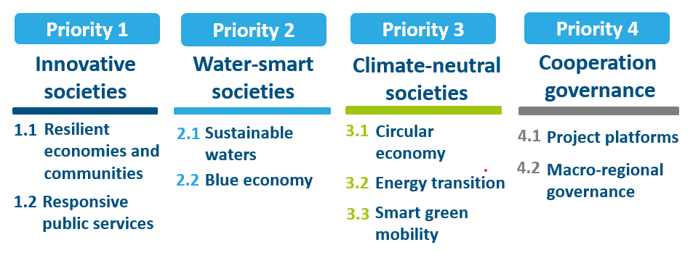

Priority 1: Innovative societies
Policy objective 1) a more competitive and smarter Europe by promoting innovative and smart economic transformation and regional ICT connectivity
Specific objective iv) developing skills for smart specialisation, industrial transition and entrepreneurship
Programme objective 1.1: Resilient economies and communities

Building sustainable, fair, innovative
and resilient economies and communities across the Baltic Sea rregion
Resilience is understood as the ability to respond to external disturbances such as severe recessions and financial crises, downturns of particular industries or major health crises. The Programme encourages actions that help to avoid unwanted external impacts, withstand them or recover quickly from them.
The focus of the Programme objective 1.1 is to:
- strengthen European identity based on common values, culture and heritage
- increase innovativeness of the region
- adapt smart specialisation approaches
- adjust innovation ecosystems
- untap digitalisation
- consider uneven territorial development
Examples of transnational cooperation actions (non-exhaustive list):
- Redesigning smart specialisation approaches and redefining connections to global value chains;
- Developing and testing mechanisms that manage economic and societal challenges in the BSR macro-region in a coordinated fashion, e.g. piloting smart health solutions;
- Exploring the potential of sustainable consumption patterns based on local services and goods;
- Exploring solutions to assist business with recovery following unexpected external disturbances.

Specific objective i) Developing and enhancing research and innovation capacities and the uptake of advanced technologies
Programme objective 1.2: Responsive public services

Experimenting with new ways of delivering public services using innovative, data-driven and participatory methods to improve the lives of citizens
In relation to a growing complexity of societal challenges, the Programme supports actions that improve organisational set-ups and processes to respond to public needs and to deliver less bureaucratic and more cost-efficient public services.
The focus of the Programme objective 1.2 is to:
- deliver tailor-made, needs-based and cost-efficient services
- harmonise systems and standards
- develop solutions responsive to change
- apply emerging digital technologies
- trigger interactions between service providers and the community
- develop public responses across sectors and borders
Example of transnational cooperation actions (non-exhaustive list):
- Developing integrated public services tailored to the needs of functional regions and specific territories;
- Developing common standards and establishing sustainable, inclusive and trustworthy digital public services in the Baltic Sea region including by piloting interoperable public services;
- Testing approaches that establish “innovation partnerships” by combining research and public procurement with the objective to create new business opportunities;
- Piloting solutions that increase citizen engagement in transforming public services.

Priority 2: Water-smart societies
Policy objective 2) a greener, low-carbon transitioning towards a net zero carbon economy and resilient Europe by promoting clean and fair energy transition, green and blue investment, the circular economy, climate change mitigation and adaptation and risk prevention and management, and sustainable urban mobility
Specific objective v) Promoting access to water and sustainable water management
Programme objective 2.1: Sustainable waters

Intensifying implementation of good practices by public authorities, industries and local communities to make the Baltic Sea and regional water resources cleaner and adapted to the impacts of climate change
The Programme supports actions that improve the state of water in the region and make its management more sustainable. These waters include the Baltic Sea, coastal waters and inland waters like rivers, lakes and groundwater.
The focus of the Programme objective 2.1 is to:
- adapt existing solutions, develop and implement new solutions in order to prevent and reduce water pollution
- adapt water management practices to the changing climate
- implement cross-sectoral actions
Examples of transnational cooperation actions (non-exhaustive list):
- Engaging authorities, companies and advisories to introduce good practices to prevent nutrient and hazardous substance emissions in water;
- Introducing procedures to remove nutrients and hazardous substances from waterways and wastewater treatment;
- Rethinking planning processes for more effective water management, also developing greening plans, nature-based and digital solutions;
- Piloting actions to shift consumer and production patterns to prevent water pollution.

Programme objective 2.2: Blue economy
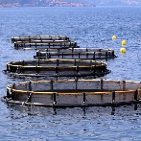
Strengthening blue economy and mitigating potential conflicts among users of the Sea space to enable sustainable use of water and marine resources adapting to the changing climate
The Programme supports actions on sustainable use of fresh and sea waters as well as marine resources in innovative business development in the whole region in emerging and established sectors. These include aquaculture, blue biotechnology, shipping, fishery, and coastal and maritime tourism.
The focus of the Programme objective 2.2 is to:
- encourage actions for blue businesses
- facilitate joint use of sea space and help mitigate potential conflicts
- strenthen resilience of blue businesses
- mitigate impact of blue businesses on climate change

Example of transnational cooperation actions (non-exhaustive list):
- Creating new business opportunities by developing value chains for sustainable fresh water and marine-based products and services in line with smart specialisation strategies;
- Developing governance, communication and cooperation models among public authorities and industry to promote the joint use of the sea and land space, through maritime spatial planning and land-sea interaction;
- Integrating climate change mitigation measures in blue economy development plans;
- Introducing common environmental standards and clean, digital, eco-efficient solutions on ships and in ports to reduce emissions, process and recycle waste and wastewater, prevent species from entering water bodies.

Priority 3: Climate-neutral societies
Policy objective 2) a greener, low-carbon transitioning towards a net zero carbon economy and resilient Europe by promoting clean and fair energy transition, green and blue investment, the circular economy, climate change mitigation and adaptation and risk prevention and management, and sustainable urban mobility
Specific Objective iv) Promoting the transition to a circular and resource efficient economy
Programme objective 3.1: Circular economy

Moving towards circular economy through strengthening the role of the cities and regions and re-thinking contribution of business
The Programme supports actions that facilitate the shift from linear to circular resource use. This implies keeping products and materials in use for as long as possible without increasing pressure on the environment. The holistic approach shall go beyond waste management to connect with water, energy, transport and land use.
The focus of the Programme objective 3.1 is to:
- create and promote circular environments
- redefine smart specialization approaches
- create business opportunities for environmental and societal benefits
- untap digitalisation
- mind uneven territorial effect and disadvantaged by transition processes
Example of transnational cooperation actions (non-exhaustive list):
- Integrating circular economy policies into territorial strategies and testing their implementation;
- Rethinking urban and regional planning processes in sectors key to achieving circularity (e.g. transport, water, energy, and waste management);
- Coordinating and supporting entrepreneurial and civil society initiatives in promoting circular economy and supporting change in attitudes;
- Providing support services that help businesses adopt more circular approaches.

Specific objective i) Promoting energy efficiency and reducing greenhouse gas emissions
Programme objective 3.2: Energy transition
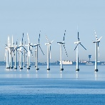
Moving towards decarbonisation of energy systems through increasing energy efficiency and investing in renewable energy in urban and rural areas
The Programme supports actions for the decarbonisation of energy systems in the region in order to reduce greenhouse gas emissions. The solutions shall increase energy efficiency in industrial production processes as well as in public and private building stock. The Programme also encourages actions to increase renewable energy production from locally available resources.
The focus of the Programme objective 3.2 is to:
- adapt and update policies for climate neutrality
- introduce energy efficiency measures and combine them with renewable energy application
- increase production and distribution of renewable energy across sectors
- coordinate plans and share solutions across borders
- mobilise industry and citizens to apply energy solutions
Example of transnational cooperation actions (non-exhaustive list):
- Addressing administrative, legal and financial barriers to speed up a ‘renovation wave’ of public and private buildings;
- Strengthening integration of different energy systems and interconnecting energy consumers from different sectors;
- Designing public support policies to encourage wider production, supply and storage of renewable energy;
- Testing guidelines for energy districts and standards for green industry certification.

Specific objective (viii) promoting sustainable multimodal urban mobility, as part of transition to a net zero carbon economy
Programme objective 3.3: Smart green mobility

Moving towards more efficient, intelligent and low-carbon transport and mobility systems
A green and well-functioning cross-border mobility system is vital for the development of the region. The Programme supports the smooth movement of people and goods in and across urban and rural areas while saving resources by increasing efficiency, integrating different transport modes and accelerating digitalisation.
The focus of the Programme objective 3.3 is to:
- harmonise mobility systems across borders
- mobilise transport companies and citizens to use smart green solutions
- support public authorities in introducing smart green solutions and reducing air
pollution in cities
Example of transnational cooperation actions (non-exhaustive list):
- Developing common standards to harmonise mobility systems in order to ensure the compatibility of green solutions along transport corridors and across borders;
- Using innovative technologies and planning infrastructure to advance low-emission, green, smart solutions in multimodal transport;
- Testing and applying digital solutions that regulate traffic flow, optimise public transport lines, and predict changing mobility patterns;
- Advancing freight mobility through introducing shared solutions and distributed centres using digital platforms to maximise the efficiency of vehicle utilisation.

Priority 4: Cooperation governance
Interreg-specific objective 'a better cooperation governance'
Specific objective vi) Other actions to support better cooperation governance
Programme objective 4.1: Project platforms

Connecting results from different EU funding programmes and making them work
The Programme supports the cooperation of EU-funded projects in project platforms. These actions bring the results of various projects to stakeholders in the Baltic Sea region in a structured way. They show how the different results complement each other, making use of synergies across EU funds.
The focus of the Programme objective 4.1 is to:
- synthesise and interlink project solutions relevant for the region
- help public authorities and other organisations access project results
- communicate and transfer solutions to broader target groups
- introduce syntheses of solutions into regional policy frameworks

Example of transnational cooperation actions (non-exhaustive list):
- Identifying solutions developed by Interreg and other EU funded projects relevant for the region and making syntheses based on the needs of the target groups;
- Analysing know-how developed in research and innovation projects as well as experiences with investment projects co-financed from EU funds and combining them with the findings of Interreg projects;
- Introducing syntheses of solutions into the daily work of public authorities, specialised agencies and others organisations working in these thematic areas;
- Reaching out to policy and decision-making authorities at the national and pan-Baltic level and providing them streamlined results from projects.

Specific objective iv) Enhance institutional capacity of public authorities and stakeholders to implement macro-regional strategies and sea-basin strategies, as well as other territorial strategies
Programme objective 4.2: Macro-regional governance
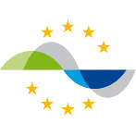
Strengthening coordination and communication of the EU Strategy for the Baltic Sea region
The Programme supports actions that implement and strengthen governance and communication activities in the EU Strategy for the Baltic Sea Region (EUSBSR). They shall facilitate policy discussions and trigger policy changes, build up networks to develop projects and other initiatives in line with the EUSBSR Action Plan.
The focus of the Programme objective 4.2 is to:
- support the coordinators of the EUSBSR policy areas in implementing their policy areas and engaging with stakeholders
- provide assistance to the national coordinators of the EUSBSR and a strategy point
- support informing about the developments and topical issues within the EUSBSR Action Plan and the achievements of the EUSBSR policy areas,
- for encourage synergies between the EUSBSR and the strategies of the partner countries
Support provided to the EUSBSR governance:
- Assistance to the policy area coordinators of the EUSBSR;
- Organisation of Strategy forums;
- Assistance to a Strategy point.

BUDGET

 | Fund | Basis for calculation  EU support  (total or public) | EU contribution  (a) | National contribution  (b) = (c) + (d) | Indicative breakdown of the national counterpart |  | Total  (e) = (a) + (b) | Co-financing rate  (f) = (a)/(e)
 |  |  |  |  | National public  (c) | National private  (d) | Total  (e) = (a) + (b) | Co-financing rate  (f) = (a)/(e)
Priority axis 1 | ERDF | total eligible cost | 58,309,503 | 14,577,376 | 12,390,769 | 2,186,606 | 72,886,879 | 0.80
Priority axis 1 | NDICI | total eligible cost
Priority axis 2 | ERDF | total eligible cost | 58,309,503 | 14,577,376 | 12,390,769 | 2,186,606 | 72,886,879 | 0.80
Priority axis 2 | NDICI | total eligible cost
Priority axis 3 | ERDF | total eligible cost | 87,464,254 | 21,866,064 | 18,586,154 | 3,279,910 | 109,330,318 | 0.80
Priority axis 3 | NDICI | total eligible cost
Priority axis 4 | ERDF | total eligible cost | 25,223,774 | 6,305,943 | 5,990,646 | 315,297 | 31,529,717 | 0.80
Priority axis 4 | NDICI | total eligible cost
Total Projects | ERDF |  | 229,307,034 | 57,326,758 | 49,358,339 | 7,968,419 | 286,633,792 | 0.80
Total Projects | NDICI
Total TA | ERDF |  | 19,939,742 | 4,984,936 | 4,984,936 | 0 | 24,924,678 | 0.80
Total TA | NDICI
Total | All funds |  | 249,246,776 | 62,311,694 | 54,343,275 | 7,968,419 | 311,558,470 | 0.80

